

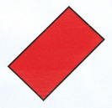



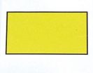

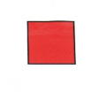

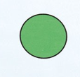

Go with the Beebot to the big yellow circle.

Go with the Beebot to the middle size yellow triangle.

Go with the Beebot to the big green square.

Go with the Beebot to the big blue triangle.

Go with the Beebot to the big blue circle.

Go with the Beebot to the small green circle.

Go with the Beebot to the small blue square.

Go with the Beebot to the small green triangle.

Go with the Beebot to the big yellow square.

Go with the Beebot to the middle size red circle.

Go with the Beebot to the big red triangle.

Go with the Beebot to the small red square.

Go with the Beebot to the big green rectancle.

Go with the Beebot to the middle size red rectancle.

Go with the Beebot to the middle size yellow rectancle.

Go with the Beebot to the small blue rectancle.