**X**

[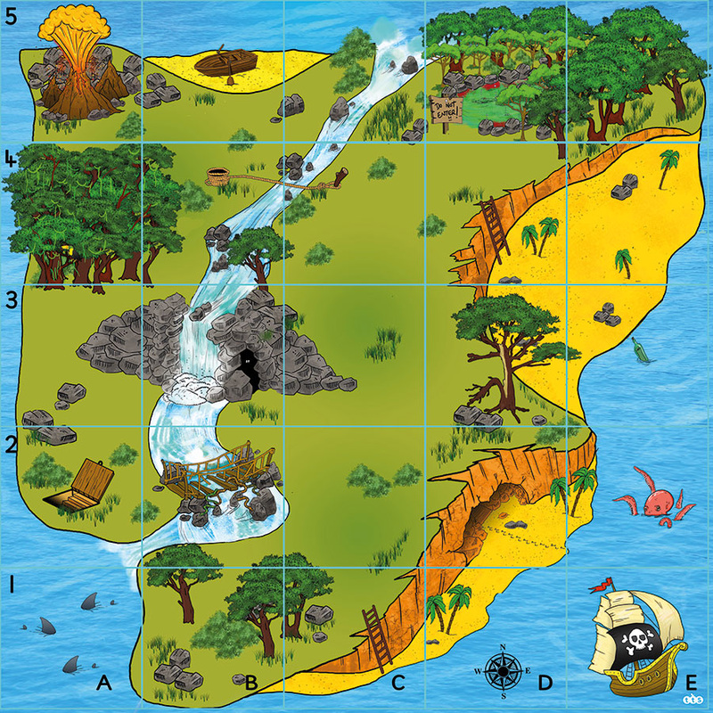](http://www.google.nl/url?sa=i&rct=j&q=&esrc=s&source=images&cd=&cad=rja&uact=8&ved=0ahUKEwj9zfX-sPHQAhXLsxQKHUI8BpwQjRwIBw&url=http://ictbethb-b.weebly.com/cdp-scenario.html&psig=AFQjCNFWgln3LYTkJH_kyeZ0fesQ9mPdMw&ust=1481725811660852)

[](http://www.google.nl/url?sa=i&rct=j&q=&esrc=s&source=images&cd=&cad=rja&uact=8&ved=0ahUKEwj9zfX-sPHQAhXLsxQKHUI8BpwQjRwIBw&url=http://ictbethb-b.weebly.com/cdp-scenario.html&psig=AFQjCNFWgln3LYTkJH_kyeZ0fesQ9mPdMw&ust=1481725811660852)

[](http://www.google.nl/url?sa=i&rct=j&q=&esrc=s&source=images&cd=&cad=rja&uact=8&ved=0ahUKEwj9zfX-sPHQAhXLsxQKHUI8BpwQjRwIBw&url=http://ictbethb-b.weebly.com/cdp-scenario.html&psig=AFQjCNFWgln3LYTkJH_kyeZ0fesQ9mPdMw&ust=1481725811660852)

[](http://www.google.nl/url?sa=i&rct=j&q=&esrc=s&source=images&cd=&cad=rja&uact=8&ved=0ahUKEwj9zfX-sPHQAhXLsxQKHUI8BpwQjRwIBw&url=http://ictbethb-b.weebly.com/cdp-scenario.html&psig=AFQjCNFWgln3LYTkJH_kyeZ0fesQ9mPdMw&ust=1481725811660852)

[](http://www.google.nl/url?sa=i&rct=j&q=&esrc=s&source=images&cd=&cad=rja&uact=8&ved=0ahUKEwj9zfX-sPHQAhXLsxQKHUI8BpwQjRwIBw&url=http://ictbethb-b.weebly.com/cdp-scenario.html&psig=AFQjCNFWgln3LYTkJH_kyeZ0fesQ9mPdMw&ust=1481725811660852)

[](http://www.google.nl/url?sa=i&rct=j&q=&esrc=s&source=images&cd=&cad=rja&uact=8&ved=0ahUKEwj9zfX-sPHQAhXLsxQKHUI8BpwQjRwIBw&url=http://ictbethb-b.weebly.com/cdp-scenario.html&psig=AFQjCNFWgln3LYTkJH_kyeZ0fesQ9mPdMw&ust=1481725811660852)

[](http://www.google.nl/url?sa=i&rct=j&q=&esrc=s&source=images&cd=&cad=rja&uact=8&ved=0ahUKEwj9zfX-sPHQAhXLsxQKHUI8BpwQjRwIBw&url=http://ictbethb-b.weebly.com/cdp-scenario.html&psig=AFQjCNFWgln3LYTkJH_kyeZ0fesQ9mPdMw&ust=1481725811660852)

[](http://www.google.nl/url?sa=i&rct=j&q=&esrc=s&source=images&cd=&cad=rja&uact=8&ved=0ahUKEwj9zfX-sPHQAhXLsxQKHUI8BpwQjRwIBw&url=http://ictbethb-b.weebly.com/cdp-scenario.html&psig=AFQjCNFWgln3LYTkJH_kyeZ0fesQ9mPdMw&ust=1481725811660852)

[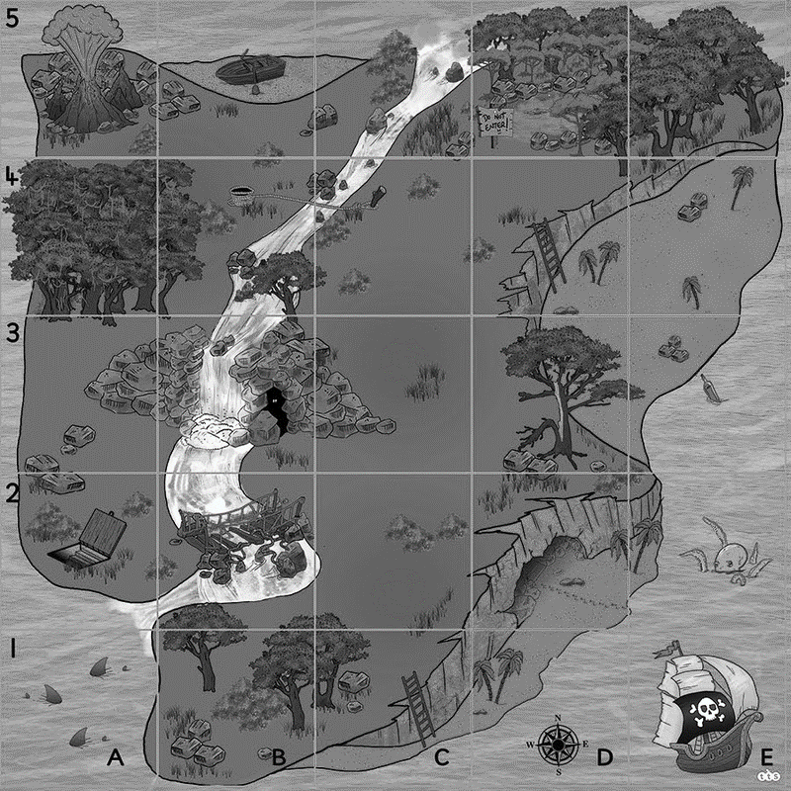](http://www.google.nl/url?sa=i&rct=j&q=&esrc=s&source=images&cd=&cad=rja&uact=8&ved=0ahUKEwj9zfX-sPHQAhXLsxQKHUI8BpwQjRwIBw&url=http://ictbethb-b.weebly.com/cdp-scenario.html&psig=AFQjCNFWgln3LYTkJH_kyeZ0fesQ9mPdMw&ust=1481725811660852)

[](http://www.google.nl/url?sa=i&rct=j&q=&esrc=s&source=images&cd=&cad=rja&uact=8&ved=0ahUKEwj9zfX-sPHQAhXLsxQKHUI8BpwQjRwIBw&url=http://ictbethb-b.weebly.com/cdp-scenario.html&psig=AFQjCNFWgln3LYTkJH_kyeZ0fesQ9mPdMw&ust=1481725811660852)

[](http://www.google.nl/url?sa=i&rct=j&q=&esrc=s&source=images&cd=&cad=rja&uact=8&ved=0ahUKEwj9zfX-sPHQAhXLsxQKHUI8BpwQjRwIBw&url=http://ictbethb-b.weebly.com/cdp-scenario.html&psig=AFQjCNFWgln3LYTkJH_kyeZ0fesQ9mPdMw&ust=1481725811660852)

[](http://www.google.nl/url?sa=i&rct=j&q=&esrc=s&source=images&cd=&cad=rja&uact=8&ved=0ahUKEwj9zfX-sPHQAhXLsxQKHUI8BpwQjRwIBw&url=http://ictbethb-b.weebly.com/cdp-scenario.html&psig=AFQjCNFWgln3LYTkJH_kyeZ0fesQ9mPdMw&ust=1481725811660852)

[](http://www.google.nl/url?sa=i&rct=j&q=&esrc=s&source=images&cd=&cad=rja&uact=8&ved=0ahUKEwj9zfX-sPHQAhXLsxQKHUI8BpwQjRwIBw&url=http://ictbethb-b.weebly.com/cdp-scenario.html&psig=AFQjCNFWgln3LYTkJH_kyeZ0fesQ9mPdMw&ust=1481725811660852)

[](http://www.google.nl/url?sa=i&rct=j&q=&esrc=s&source=images&cd=&cad=rja&uact=8&ved=0ahUKEwj9zfX-sPHQAhXLsxQKHUI8BpwQjRwIBw&url=http://ictbethb-b.weebly.com/cdp-scenario.html&psig=AFQjCNFWgln3LYTkJH_kyeZ0fesQ9mPdMw&ust=1481725811660852)

[](http://www.google.nl/url?sa=i&rct=j&q=&esrc=s&source=images&cd=&cad=rja&uact=8&ved=0ahUKEwj9zfX-sPHQAhXLsxQKHUI8BpwQjRwIBw&url=http://ictbethb-b.weebly.com/cdp-scenario.html&psig=AFQjCNFWgln3LYTkJH_kyeZ0fesQ9mPdMw&ust=1481725811660852)

[](http://www.google.nl/url?sa=i&rct=j&q=&esrc=s&source=images&cd=&cad=rja&uact=8&ved=0ahUKEwj9zfX-sPHQAhXLsxQKHUI8BpwQjRwIBw&url=http://ictbethb-b.weebly.com/cdp-scenario.html&psig=AFQjCNFWgln3LYTkJH_kyeZ0fesQ9mPdMw&ust=1481725811660852)

[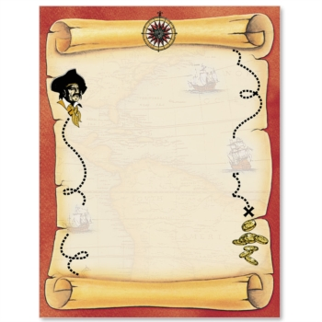](http://www.google.nl/url?sa=i&rct=j&q=&esrc=s&source=images&cd=&cad=rja&uact=8&ved=0ahUKEwiPsobZ6PHQAhXBdFAKHd9jC1EQjRwIBw&url=http://www.paperdirect.com/treasure-map-border-papers/-113265&bvm=bv.141320020,d.ZGg&psig=AFQjCNFBLzD1lssht_DAgv0s2epGTZU3Bg&ust=1481740696409615)

***Volg de route naar de schat!***

***E 1***

***C 1***

***C 4***

***A 4***

[](http://www.google.nl/url?sa=i&rct=j&q=&esrc=s&source=images&cd=&cad=rja&uact=8&ved=0ahUKEwiPsobZ6PHQAhXBdFAKHd9jC1EQjRwIBw&url=http://www.paperdirect.com/treasure-map-border-papers/-113265&bvm=bv.141320020,d.ZGg&psig=AFQjCNFBLzD1lssht_DAgv0s2epGTZU3Bg&ust=1481740696409615)

***Volg de route naar de schat!***

***E 1***

***E 5***

***D 5***

***D 4***

***B 4***

[](http://www.google.nl/url?sa=i&rct=j&q=&esrc=s&source=images&cd=&cad=rja&uact=8&ved=0ahUKEwiPsobZ6PHQAhXBdFAKHd9jC1EQjRwIBw&url=http://www.paperdirect.com/treasure-map-border-papers/-113265&bvm=bv.141320020,d.ZGg&psig=AFQjCNFBLzD1lssht_DAgv0s2epGTZU3Bg&ust=1481740696409615)

***Volg de route naar de schat!***

***E 1***

***E 3***

***B 3***

***B 2***

***A 2***

[](http://www.google.nl/url?sa=i&rct=j&q=&esrc=s&source=images&cd=&cad=rja&uact=8&ved=0ahUKEwiPsobZ6PHQAhXBdFAKHd9jC1EQjRwIBw&url=http://www.paperdirect.com/treasure-map-border-papers/-113265&bvm=bv.141320020,d.ZGg&psig=AFQjCNFBLzD1lssht_DAgv0s2epGTZU3Bg&ust=1481740696409615)

***Volg de route naar de schat!***

***E 1***

***E 2***

***D 2***

***D 1***

***C 1***

[](http://www.google.nl/url?sa=i&rct=j&q=&esrc=s&source=images&cd=&cad=rja&uact=8&ved=0ahUKEwiPsobZ6PHQAhXBdFAKHd9jC1EQjRwIBw&url=http://www.paperdirect.com/treasure-map-border-papers/-113265&bvm=bv.141320020,d.ZGg&psig=AFQjCNFBLzD1lssht_DAgv0s2epGTZU3Bg&ust=1481740696409615)

***Volg de route naar de schat!***

***E 1***

***E 4***

***D 4***

***D 3***

***C 3***

[](http://www.google.nl/url?sa=i&rct=j&q=&esrc=s&source=images&cd=&cad=rja&uact=8&ved=0ahUKEwiPsobZ6PHQAhXBdFAKHd9jC1EQjRwIBw&url=http://www.paperdirect.com/treasure-map-border-papers/-113265&bvm=bv.141320020,d.ZGg&psig=AFQjCNFBLzD1lssht_DAgv0s2epGTZU3Bg&ust=1481740696409615)

***Volg de route naar de schat!***

***E 1***

***C 1***

***C 3***

***A 3***

***A 5***

[](http://www.google.nl/url?sa=i&rct=j&q=&esrc=s&source=images&cd=&cad=rja&uact=8&ved=0ahUKEwiPsobZ6PHQAhXBdFAKHd9jC1EQjRwIBw&url=http://www.paperdirect.com/treasure-map-border-papers/-113265&bvm=bv.141320020,d.ZGg&psig=AFQjCNFBLzD1lssht_DAgv0s2epGTZU3Bg&ust=1481740696409615)

***Volg de route naar de schat!***

***B 5***

***B 4***

***D 3***

***E 3***

***E 2***

[](http://www.google.nl/url?sa=i&rct=j&q=&esrc=s&source=images&cd=&cad=rja&uact=8&ved=0ahUKEwiPsobZ6PHQAhXBdFAKHd9jC1EQjRwIBw&url=http://www.paperdirect.com/treasure-map-border-papers/-113265&bvm=bv.141320020,d.ZGg&psig=AFQjCNFBLzD1lssht_DAgv0s2epGTZU3Bg&ust=1481740696409615)

***Volg de route naar de schat!***

***C 1***

***C 4***

***D 4***

***D 5***

Je gaat op wereldreis. Je begint in Australië, je gaat op reis naar de Verenigde Staten, je reist zoveel mogelijk over zee.

Je gaat op wereldreis. Je bent in de Verenigde Staten, je gaat op reis naar Japan, je vaart langs Kaap de Goede hoop.

Je gaat op wereldreis. Je bent in Brazilië, je gaat naar Ghana, van daaruit ga je naar Iran. Je eindigt je reis in China.

Je gaat op wereldreis. Je bent in China, van daaruit reis je via Rusland naar Europa. Daarna reis je via Scandinavië naar Groenland.

Je gaat op wereldreis. Je bent in Groenland. Je reist via Canada door de Verenigde Staten en Mexico naar Chili. Je vaart langs Hawaï en eindigt in Alaska.

Je gaat op wereldreis. Je bent in Alaska van daaruit ga je via Canada naar Portugal. Van daaruit ga je via het Suezkanaal in Egypte naar India.

Je bent in India. Je gaat langs Madagaskar naar de Zuidpool. Van hieruit ga je met een tussenstop in Argentinië naar Europa.

Bedenk zelf een reis.

[](https://www.google.nl/url?sa=i&rct=j&q=&esrc=s&source=images&cd=&cad=rja&uact=8&ved=0ahUKEwihrLTbr4LRAhWeYFAKHVccCAYQjRwIBw&url=https%3A%2F%2Fwww.medischcontact.nl%2Farts-in-spe%2Fblogs%2Fais-blog%2Fblog-micha-de-piraat.htm&bvm=bv.142059868,d.ZWM&psig=AFQjCNFGTwq1Tp8XIKo6PL4Z8MJKZsYSGQ&ust=1482309536129838)

[](https://www.google.nl/url?sa=i&rct=j&q=&esrc=s&source=images&cd=&cad=rja&uact=8&ved=0ahUKEwihrLTbr4LRAhWeYFAKHVccCAYQjRwIBw&url=https%3A%2F%2Fwww.medischcontact.nl%2Farts-in-spe%2Fblogs%2Fais-blog%2Fblog-micha-de-piraat.htm&bvm=bv.142059868,d.ZWM&psig=AFQjCNFGTwq1Tp8XIKo6PL4Z8MJKZsYSGQ&ust=1482309536129838)